**Problems with Monolithic Architecture:**

1) Entire application is deployed as a single exe. Hence, if you make change in any layer (UI/BLL/DAL), then you need to redeploy the entire application.

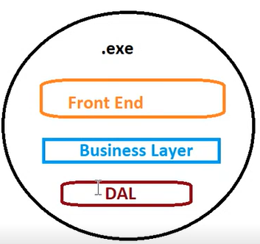

2) All the layers have to be coded using a single technology. All team members working on each layer must be aware of a technology used to code the project.

If someone doesn’t know the technology, then you may need to train the resource on that technology.

3) If you have developed application using some technology (E.g. - .NET), then environment where application is deployed should have NET. If you are deploying .NET web-based application, then deployment environment must have IIS installed. That means application has to be deployed on Windows as IIS is tied to Windows.

So, the problem is any minor changes made in the deployment environment will affect your exe.

To eliminate these problems, you had **distributed monolithic applications**.

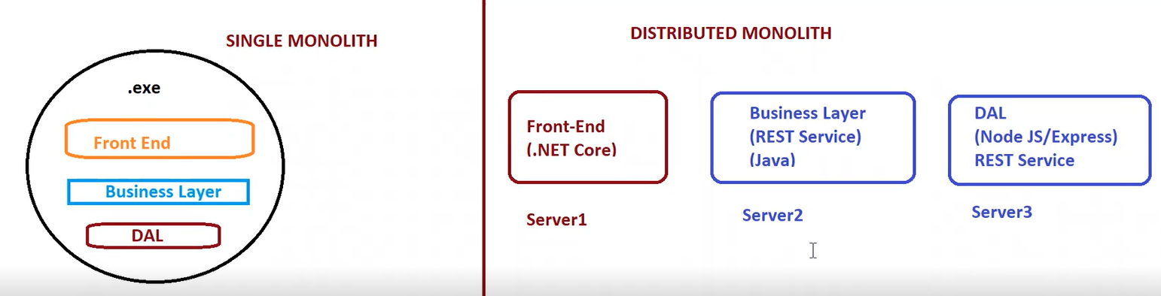

This fixes the problems if Single Monolith. But the approach is still Monolithic approach.

**Problem with Distributed Monolith:**

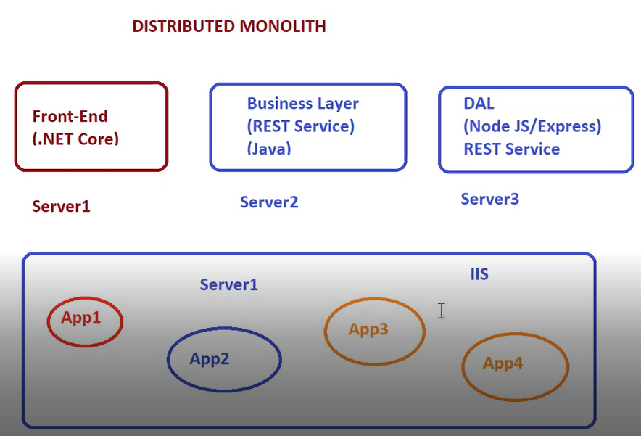

1) **All the applications are dependent on IIS.** Hence, if any configuration change is made in IIS, it will affect some applications for whom the change was not intended. Hence, those applications may need to be changed and redeployed again. Monolithic application is not self-dependent. It depends on some external environment. This problem persists even in distributed monolith.

2) Any change in external environment requires **application to be redeployed**.

3) **Difficult to Scale:** Difficult to create additional instances of a particular application on the same web server if required. There is no mechanism to recreate the application instances that have gone down. If you created replica of a server to scale a single application, then other applications which were not intended to be scaled are also scaled. Also creating a replica of a server is costly.

**Microservice Approach:**

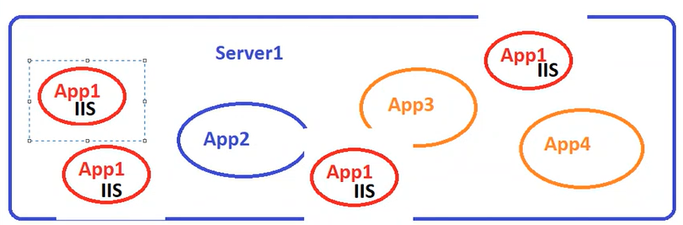

You write a Dockerfile. In that Dockerfile, you specify a base image. Then you copy the build output into that container. Effectively, you are actually converting your application to Microservice only. So, when you start that container, container has got some entry point (specified using CMD). This entry point/CMD starts a web server. Hence, deployment environment is not expected to have web server installed.

**You can deploy Microservice on any environment which knows how to handle / manage the Microservices. Kubernetes is one such platform which knows how to handle / manage the Microservices. Docker Swarm is another platform which knows that.** These are all **Container Orchestration Platforms.**

Docker is all about deploying your applications.

Deployment approach is Microservices approach. Microservices are Not an API, Not a Programming Language. It’s a way of creating and deploying applications.

Microservice is any kind of application created using any programming language. The application does not handle multiple responsibilities.

Microservice can be any application handling a single responsibility. E.g. – Patient Management System performing CRUD operations on Patients can be a Microservice.

Microservices are Self Hosted. They don’t depend on any external environment to be deployed. E.g. – If your Microservice needs a Web Server to function, when you deploy a Microservice, it will be deployed along with the web server. When you start the Microservice, it will start its own web server and it will host itself. Hence you can put that Microservice on any environment. It will execute in the same way as it executed when you developed it. This is one of the major benefits of Microservices. In simple words, Microservice is a self-hosted application which runs inside its own process. It does not require any separate environment for execution or hosting. It comes with its own self hosted environment.

Microservices are:

1) Self-Hosted

2) Can be Independently Deployed

3) Can be Independently Versioned

Docker plays a very important role when it comes to Microservices approach.

**Training Objective:**

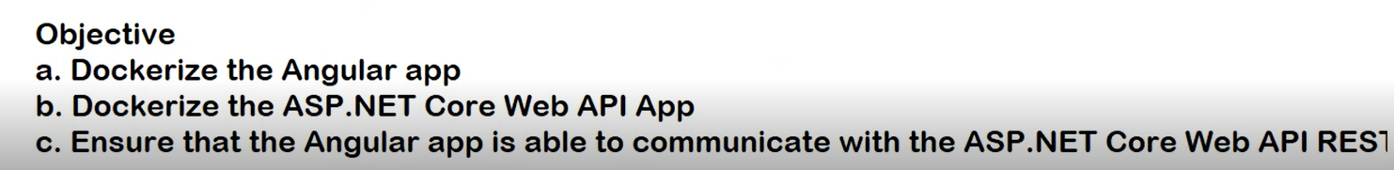

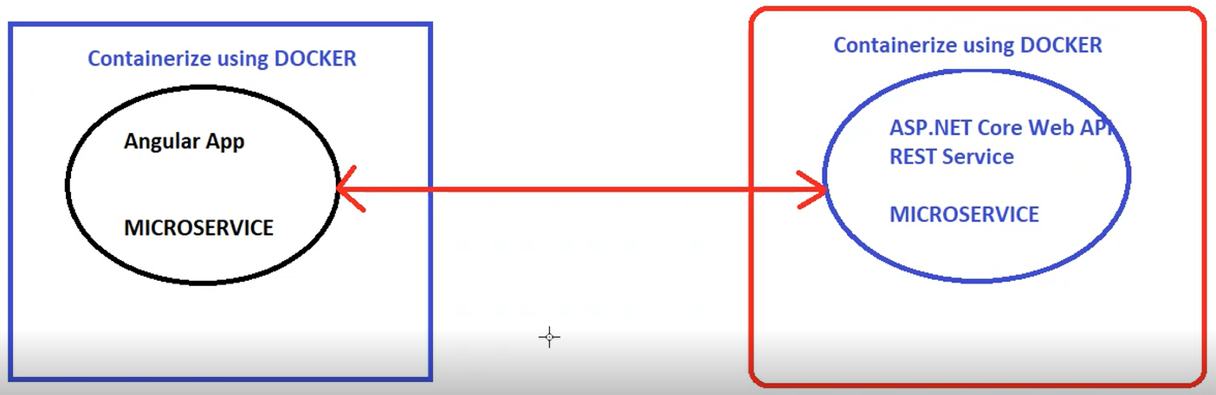

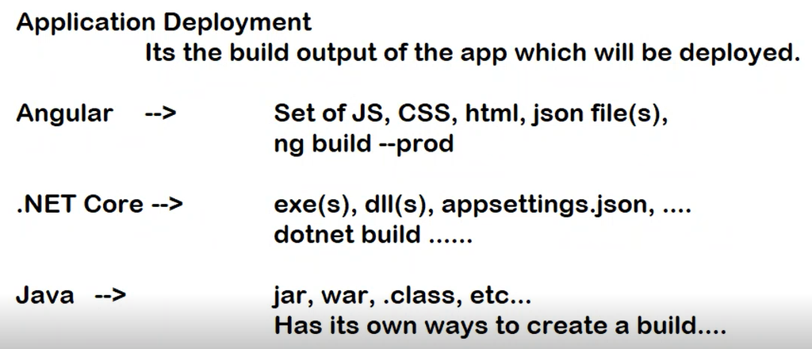

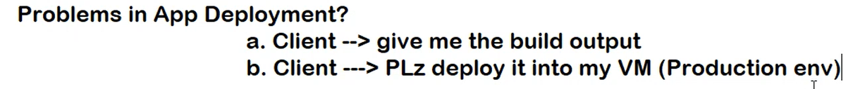

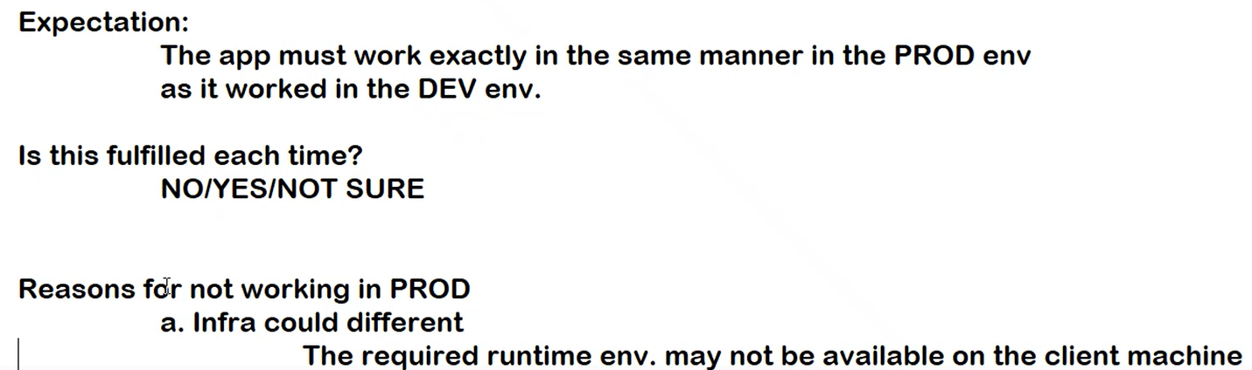

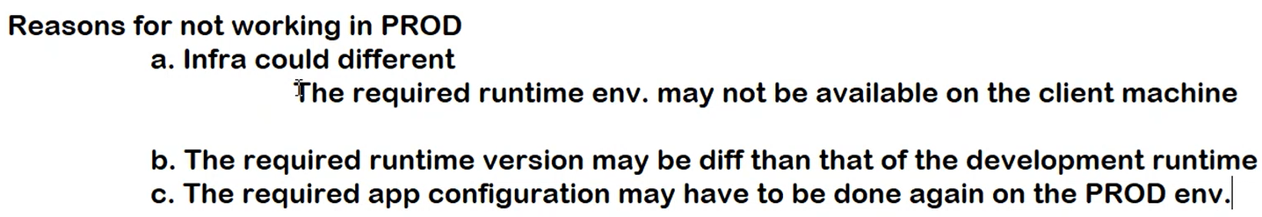

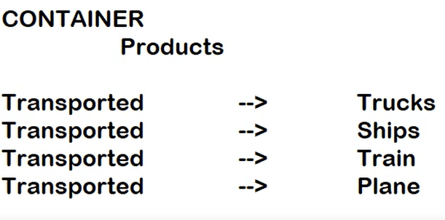

When you put the products inside the container, you package the products inside the container. You package it in such a way that they are protected. The packaging will be done in a standard way. Manner in which you package the products is the same irrespective of the mode of transport. Container solves this problem.

Without Containers, products will be packaged differently depending on a transportation medium.

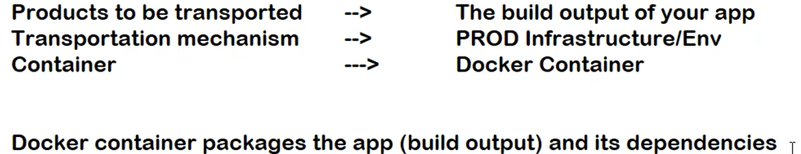

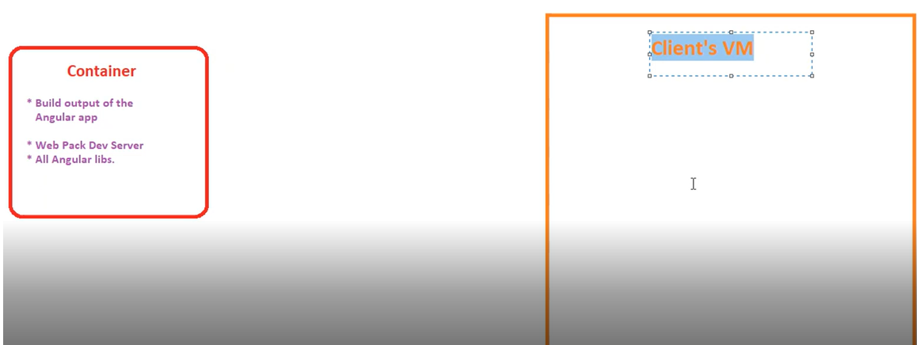

If you pick up the container and put it on Client’s VM, will your application work?

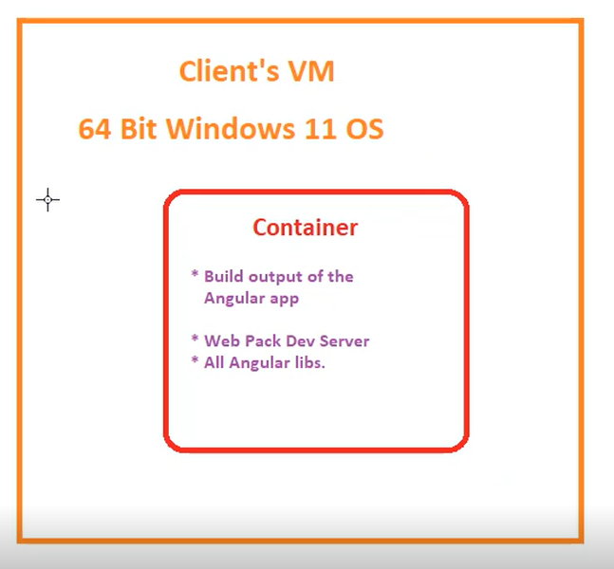

Will the app run when container is put on Windows 11 OS?

No.

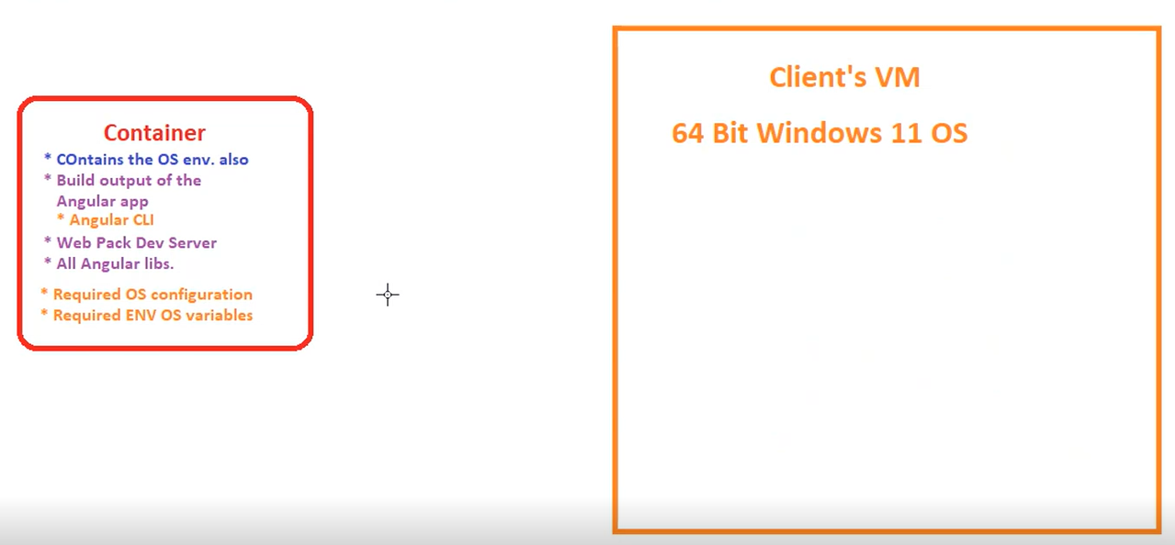

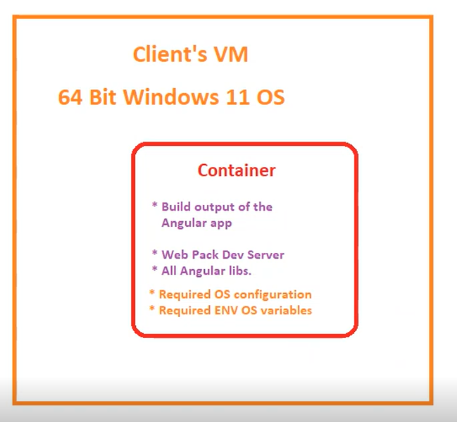

**Will the application work now? – YES. Only required thing is OS should have Docker installed. Because Docker understands how containers work.**

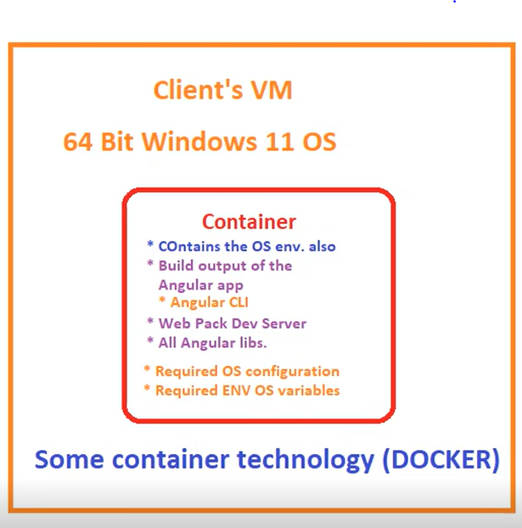

Docker as a tool simplifies creation and management of containers. You don’t need to learn that.

Docker is a container platform. It allows you to create and manage containers on any Operating System.

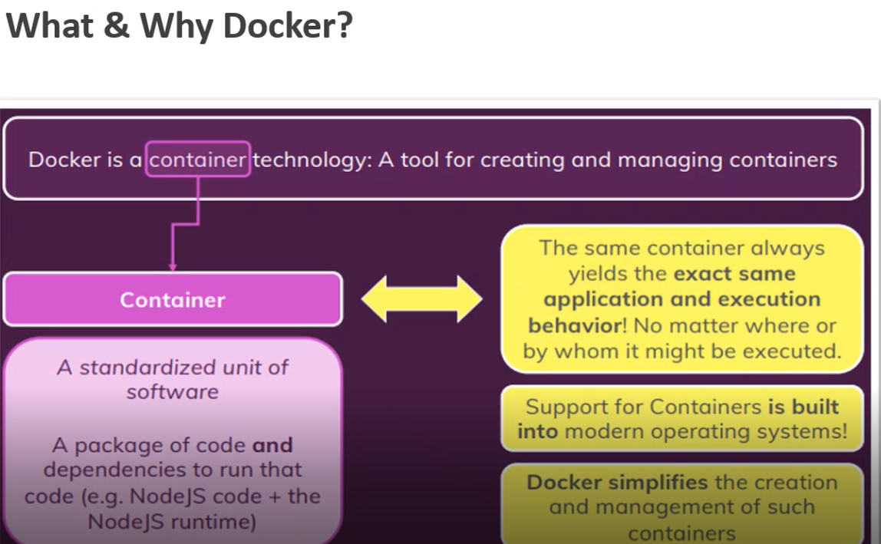

**Docker allows you to create and manage containers on any Operating System. Docker will take care of the things like How to create a container, How to start a container, How to stop a container, How to execute a container, How to destroy a container etc.**

Though Operating Systems (OSs) can manage the containers, you don’t need to learn it as Docker will take care of it. Docker gives you the layer of abstraction over OS. Docker simplifies the creation and management of containers.

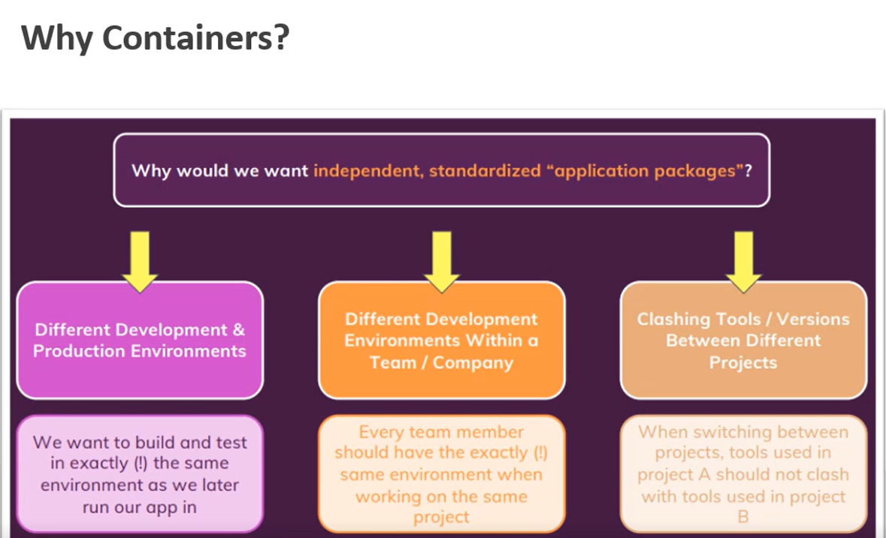

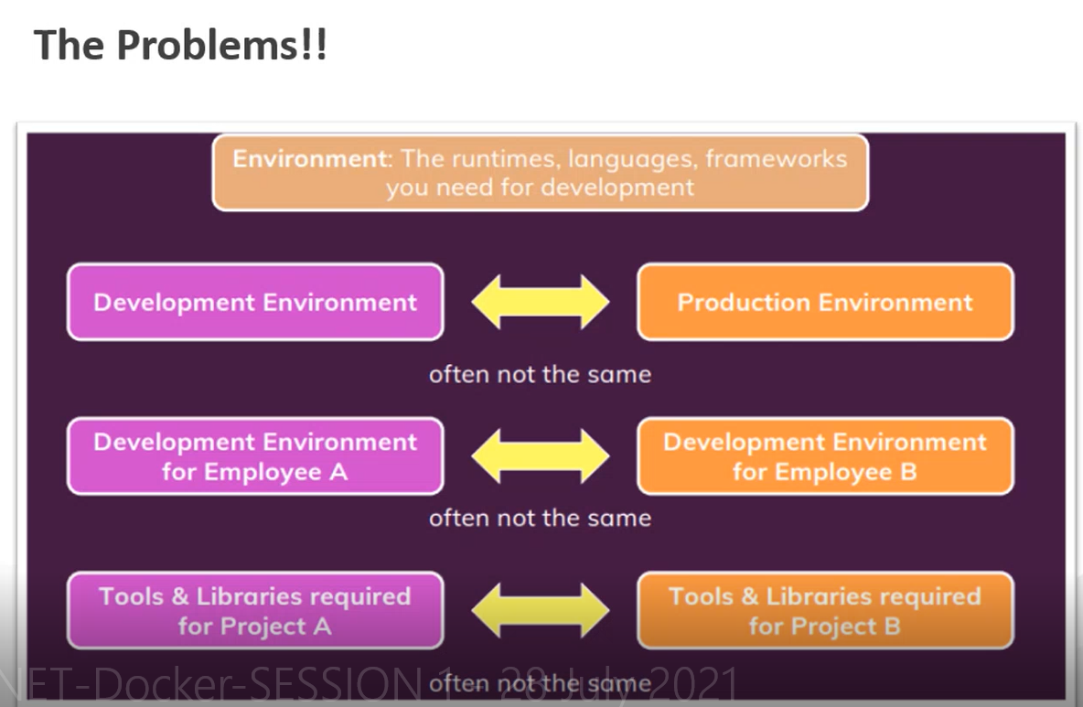

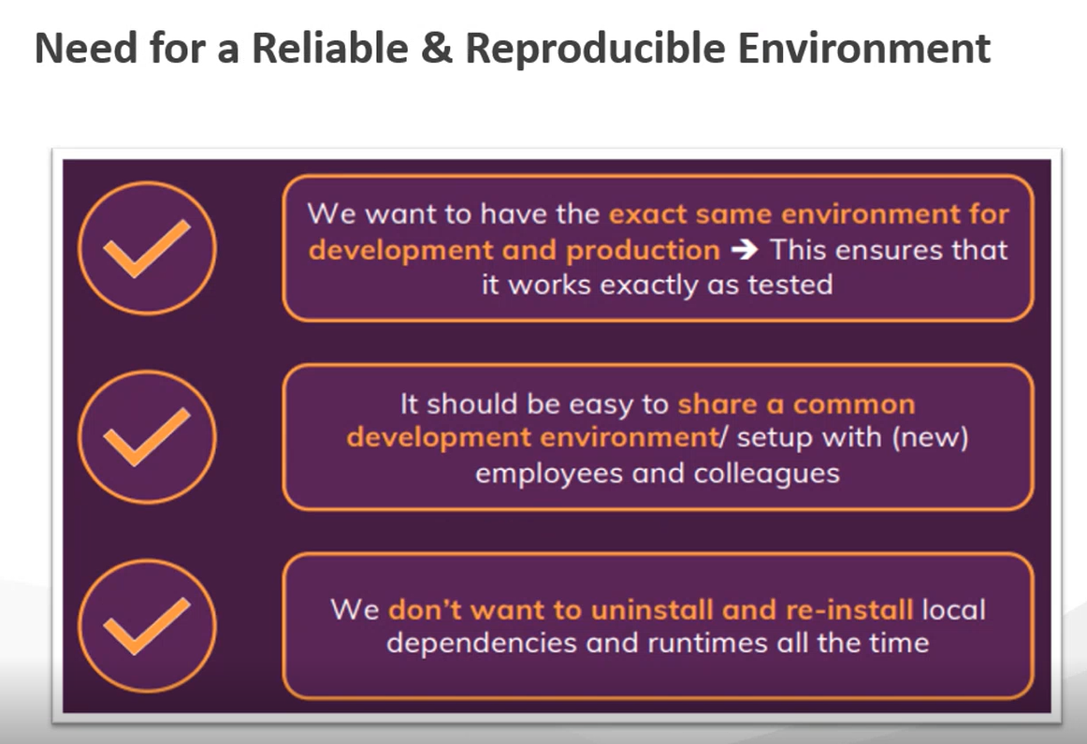

**VMs V/S Containers:**

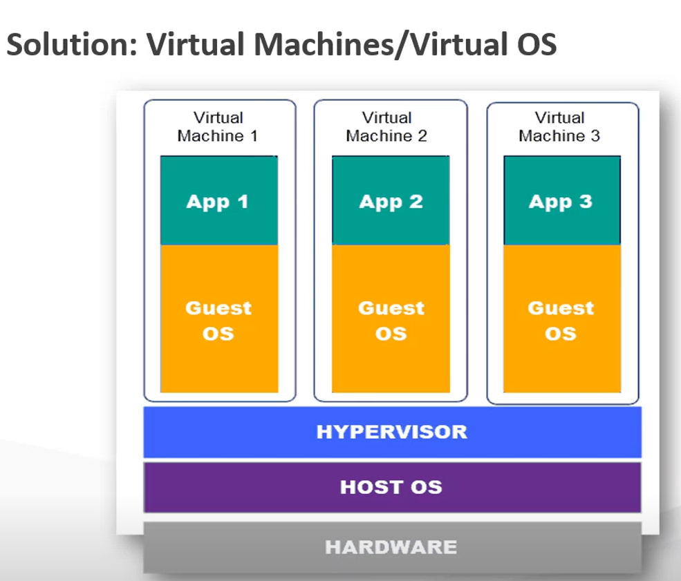

Hypervisor is a technology which allows Host OS to communicate with VMs and vice a versa. Hypervisor is a Microsoft technology.

Each VM will have its own copy of an OS. Each of those OSs will have their own copy of the Kernel. Kernel is the piece of OS that talks to hardware.

**VM Advantages:**

You can configure the environment as per your requirement on VMs. **E.g. –** One VM having Development/One VM having Staging/One VM having Production environment.

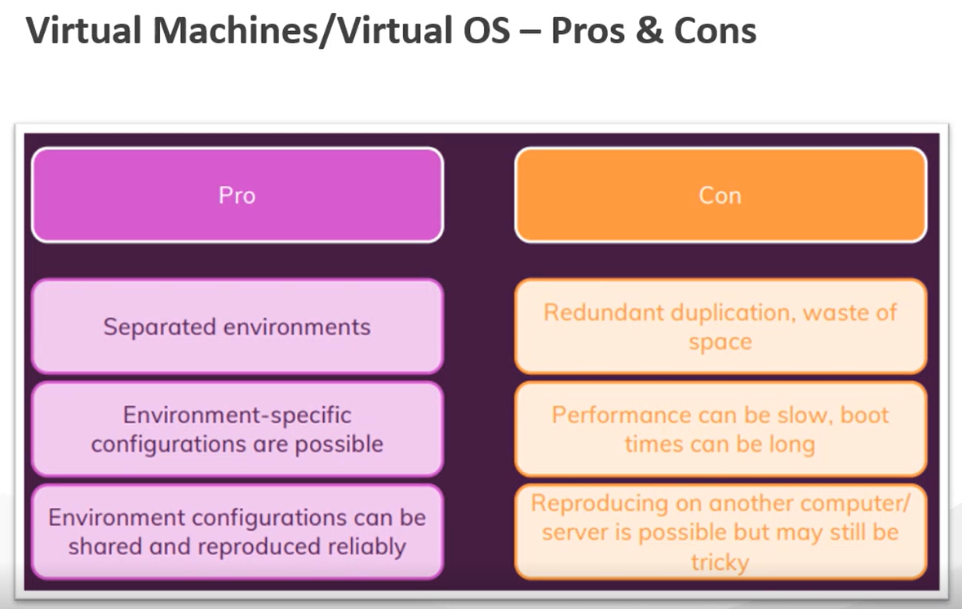

**If the VM that uses Hypervisor needs to be created on another OS, that OS must have Hypervisor. If that OS has VMWare, then VM using Hypervisor cannot be recreated on that OS.**

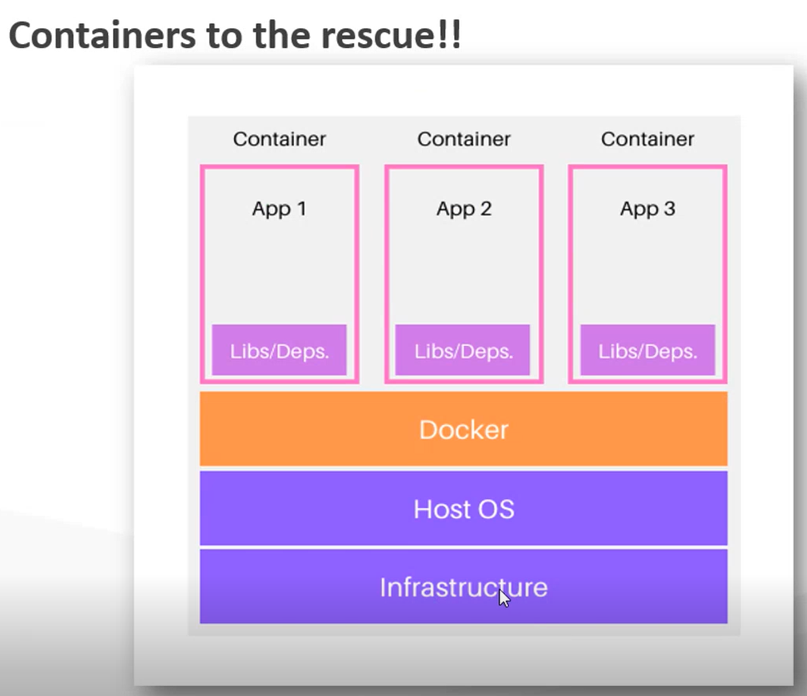

**Docker will Create the Containers.**

**Containers do not contain OS and Kernel. They contain only the app, its dependencies and basic file system of an OS.**

**They are very lightweight compared to VM image.**

**They can easily be started and stopped.**

**They share the Host Machine’s Kernel.**

**They can be easily migrated to any environment that has docker.**

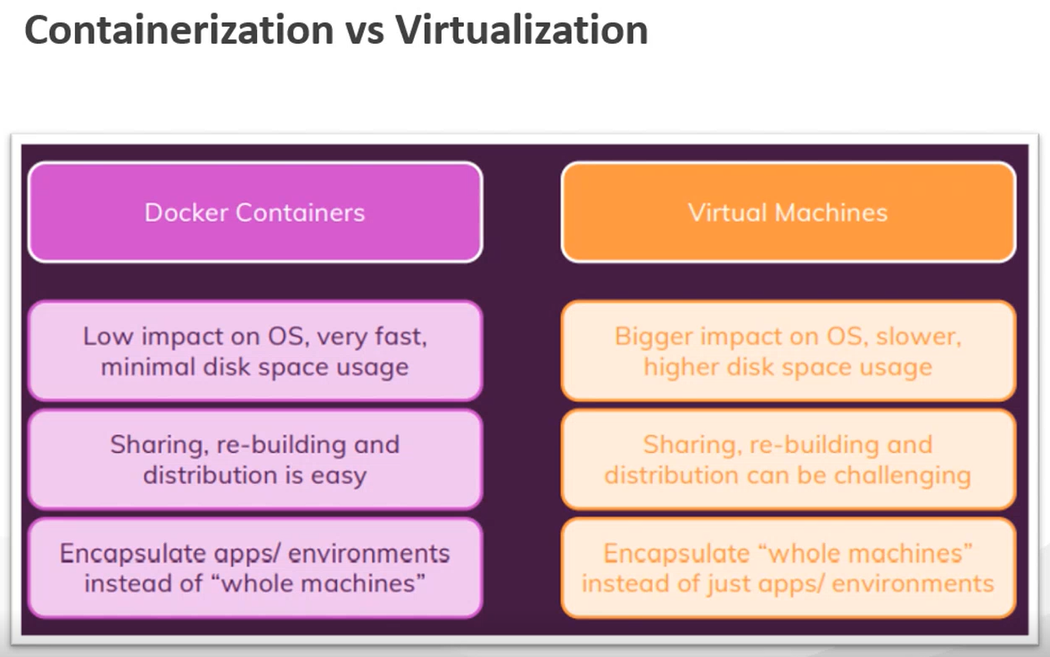

**Docker Installation Link:**



**Docker is written in Go language and it runs on natively on Linux. You can directly install Docker on Linux OS.**

**The Docker running on Linux will not run on Windows and Mac.**

**This can be done by installing Docker Desktop on Windows and Mac. Docker desktop internally creates a Linux VM and installs Docker on that VM.**

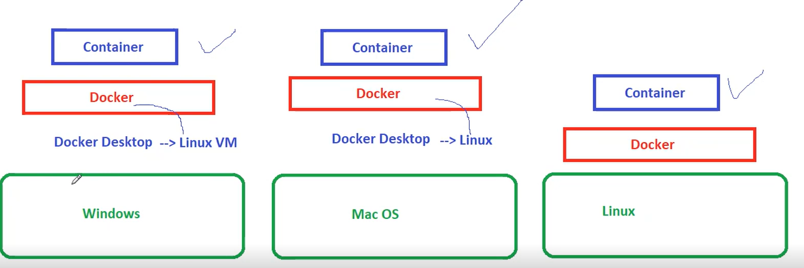

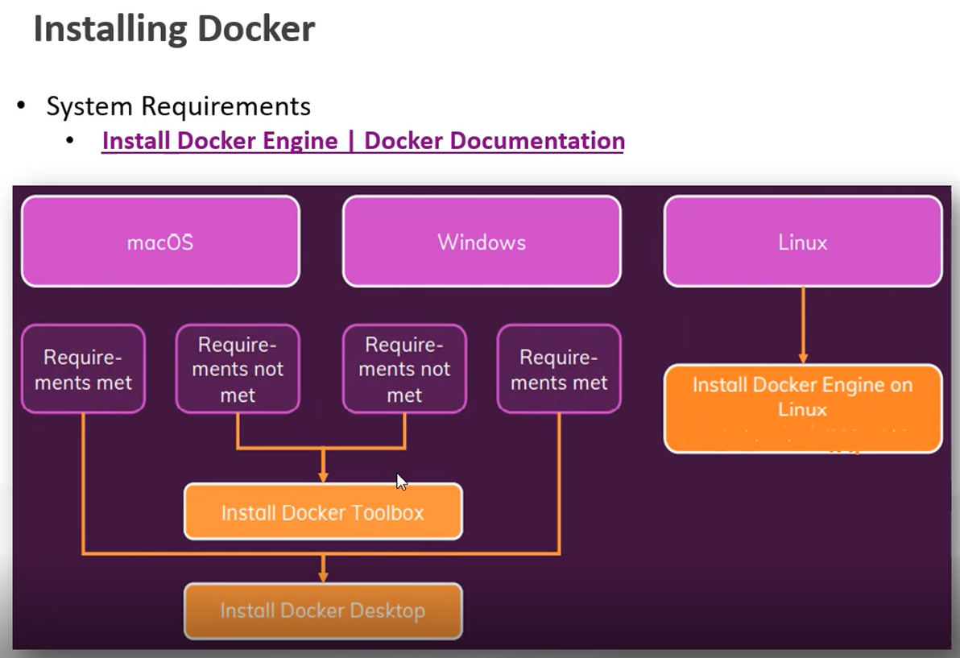

Docker Toolbox allows you to install Docker on older versions of OS.

**To SSH to Linux VM:**

Start🡪Run🡪CMD

ssh [nachiket@40.117.116.219](mailto:nachiket@40.117.116.219)

nachiket 🡪 User Name

40.117.116.219 🡪 Public IP Address of your Linux VM

Say “Yes” to the questions asked and press Enter key.

Key in the password.

Key in the following commands on Linux VM:

1) sudo su – Switches to super user (Like Administrator in Windows OS). You will see # prompt instead of $ prompt.  
2) apt-get update

To Install the Docker, Run the following Command:

3) apt-get install docker.io -y

This will download and install Docker from the Docker official web site.

4) docker version

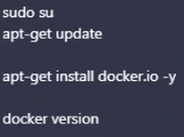

**Docker Architecture:**

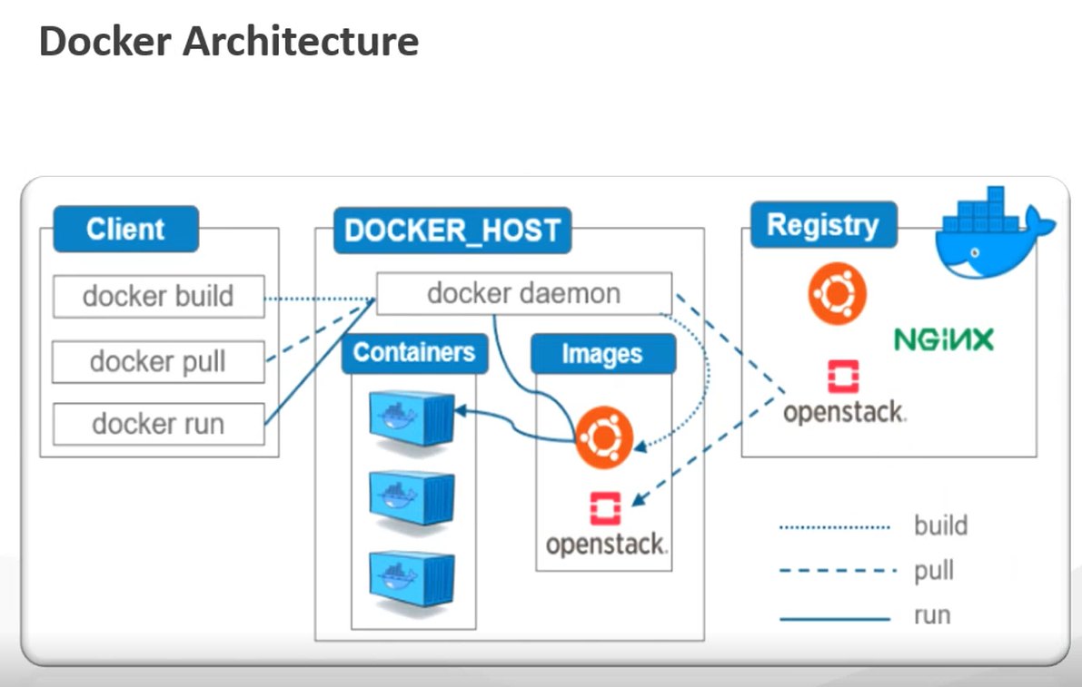

**Docker Host:** The virtual machine or may be your laptop in which Docker is installed.

Once the Docker in Installed, a Background Service is Started. That Background Service is known as Docker Daemon. Docker Daemon takes care of managing our containers, managing your images etc.

Docker Host is the Machine on which the Docker Daemon is Running.

**Docker Daemon** is going to manage your Containers and Images.

**Docker Client (Docker CLI):** The One who is Using Docker or the One who is Giving the Docker Commands.

Docker Follows Client Server Architecture.

The machine on which Docker is installed, from the same machine you can give Docker commands.

The One who Issues Docker Commands OR Machine from Where you Give Docker Commands is Docker Client.

The Same Machine can be a Docker Host and can be a Docker Client.

But it is possible to have Docker Daemon on One Machine and Docker Client on Another Machine because it is a Client Server Architecture.

Whenever you issue the Docker command, those commands are Received by Docker Daemon and Docker Daemon acts on those commands.

This means the Client will use Docker CLI to give Docker Commands to the Docker Daemon.

Docker Daemon is heart of Docker. Sometimes it is also known as Docker Engine. Daemon will take responsibility of Creating Containers, Creating Images, Creating Containers from Images,

Managing the Containers, Managing the Images.

**Registry:** Docker Hub. Collection of images. People create images and push it to the Docker Hub. Images are shared with other people by pushing them to the Docker Hub.

When you issue “docker pull” command, docker pull will tell Docker Daemon, please pull the specified image from the registry. So, Docker Daemon will connect to Docker Hub (Registry), pull that image

and give it you on your local machine and then you can create containers from that image.

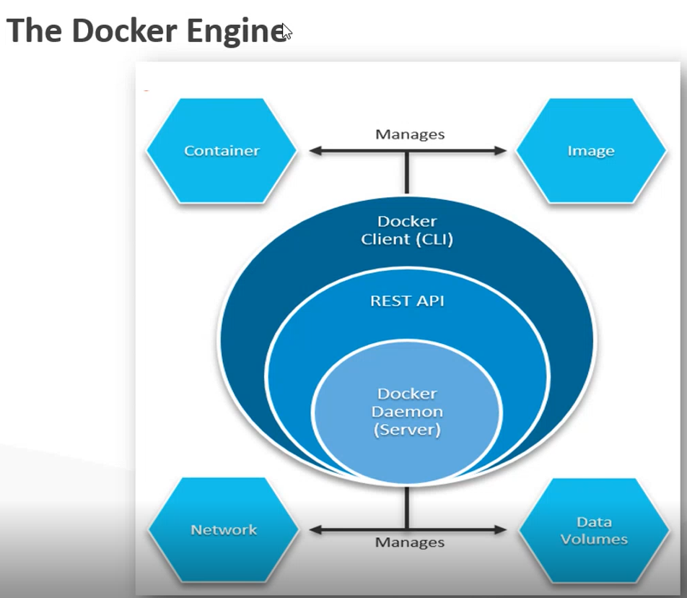

**Docker Engine: Docker Client + Docker Daemon + REST API**

Docker CLI is a Collection of Docker Commands used by Client. E.g. – docker pull, docker version

Docker Commands have to be sent to Docker Daemon.

The commands keyed in by you on Docker CLI are given to the Docker Daemon by REST API.

Docker commands internally use REST API. This REST API is already installed when you install Docker. This REST API will forward those commands to the Daemon.

Docker Daemon can perform its task only when you give command to it. You give command to it via Docker CLI.

REST APIs are abstracted in the form of Docker Commands.

Docker Daemon does Container Management, Image Management, Volume Management and Network Management.

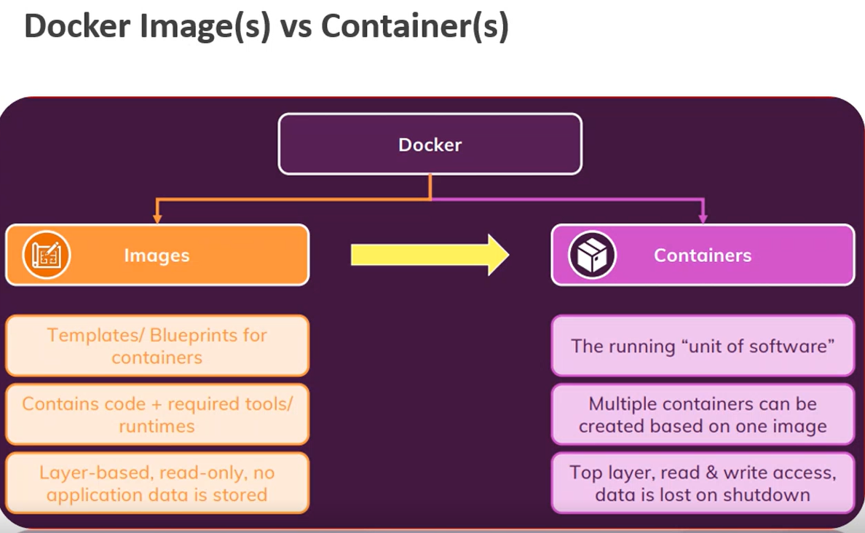

Image is a blueprint for a container. Image should define things such as When container is started what application it should host, on what port number the application should run, what dependencies it should have. Image is like creating a class. From one single image, you can create multiple containers.

Containers are like objects of the class.

Images are shared. Containers are not shared.

Containers are temporary. They are created and destroyed.

Images are permanent.

As long as you have an image, you can create a container from it. Containers are lightweight. They share host machine’s Operating System and Kernel. Hence you can spin up multiple container in no time.

You put an image in Docker Hub. People pull that image from Docker Hub and create containers from that image.

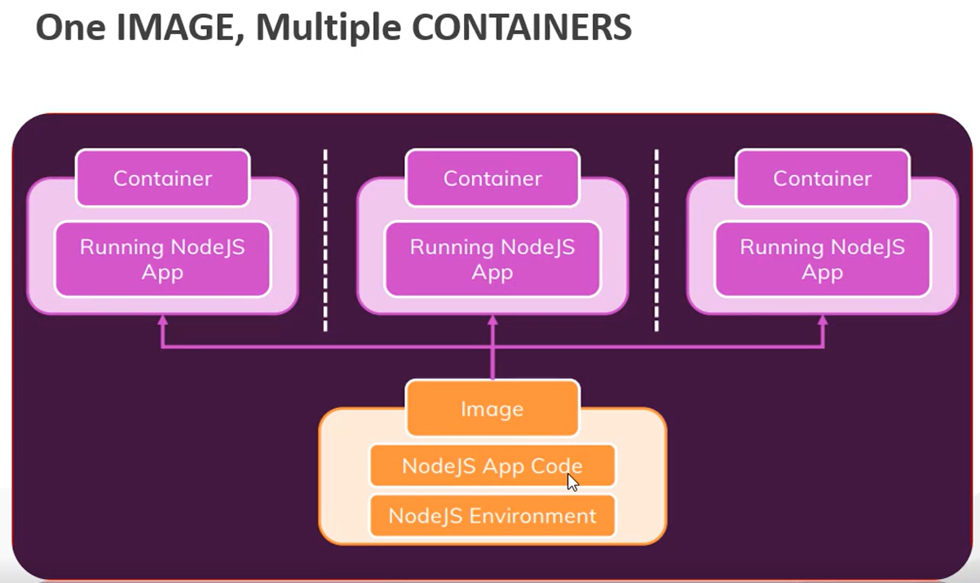

**Microservices are Hosted Inside a Container.**

In above diagram, you are hosting 3 instances of your application.

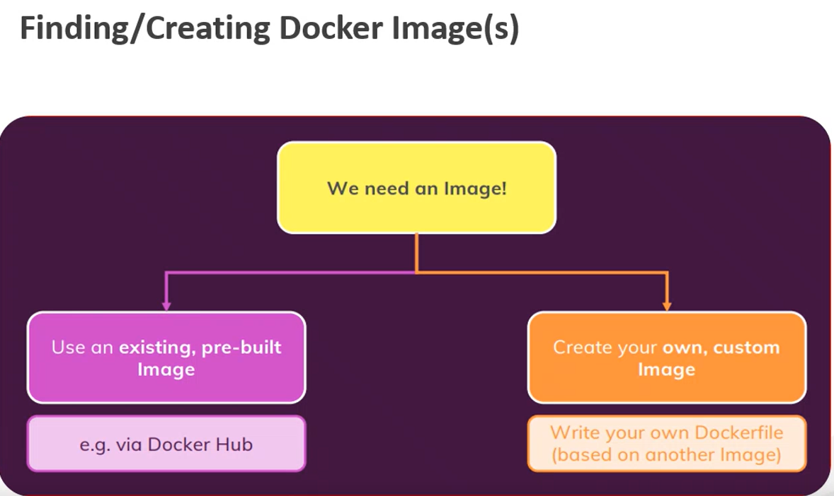

**Docker Commands:**

To check the Docker Installation:

docker - -version

To List the Images:

docker images

To Pull the Hello-World Image from Docker Hub:

docker pull hello-world

To Pull the Hello-World Image from DockerHub and Create the Container from it:

docker run --name helloworldcon hello-world

To List the Running Containers:

docker ps

To List All the Containers (Running and Exited):

docker ps -a

**List the Running Containers:**

docker ps : Lists the running containers.

docker ps -a: Lists all the containers. Lists the containers irrespective of their status. Shows the status of container as exited.

Again run “docker run --name mylinuxcontainer busybox”. You will get an error.

Run “docker run --name mylinuxcontainer1 busybox” and issue “docker ps -a” command. You will see both the containers as exited.

**Remove the container:**

docker rm <<containerid/name>>

docker rm mylinuxcontainer1

docker rm mylinuxcontainer

For container to be active, there has to some command to keep the container alive.

Creator of busybox image might have created the image in such a way that it did not contain any command. When you create a container, you have not told which command to run.

Hence the container is not alive. It exits.



sh is a shell which waits for the command to be keyed in. It is like a running process. sh is an interactive command.

Key in “exit” command at the root and run “docker ps -a” command.

-it: Starts the container and takes you inside the container using interactive container. Whenever you want to go inside the container, start it with -it.

Once the container goes to exited state, you cannot restart it. You need to remove it and recreate it.

Following command will start the container, execute date command inside it and come out.

**docker run -it --name mylinuxcontainer2 busybox date**

date is not an interactive command. Date command will be executed and container will exit.

“sh” is a default command that is executed when the busybox container is created.

“-it” allows you get into the container and troubleshoot the container.

**docker rm d631 33bd** : removes multiple containers using their IDs. You can specify first few characters from the ID.

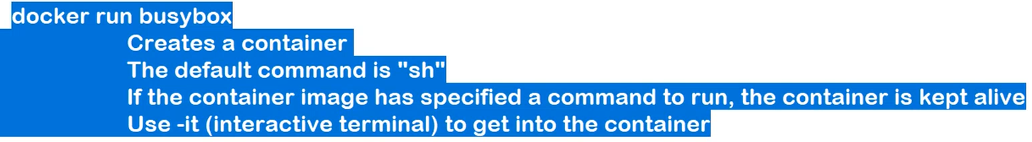

Key the following commands:

docker run -it busybox

**Inside the Container:**

ls

pwd

who

docker ps -a : Error. Docker not found. ps stands for Process Status.

**To Keep the Container Running and Come Out of it/To quit a container without terminating it:**

**Ctrl+pq (Detach)**

**Key in the following command to get into a container again:**

**docker attach <<containername>>/<<containerid>> : Container must be running.**

docker pull node

docker images

docker run node

docker ps -a

docker run -it node: You won’t see # on command prompt. You will see > on command prompt.

Key in some console.log statements. To exit, press Ctrl+C twice or press Ctrl+D.

**How to execute command inside a running container:**

docker run -d -it --name busyboxcon busybox

docker exec <<containername>> <<commandname>>: Executes a command in a running container without going into it/without attaching.

Exit command will Stop and Detach the Container.

You can start the exited container.

**How to stop a running container:**

docker stop **<<containername>>/<<containerid>>**

**To Start the Stopped Container:**

docker start **<<containername>>/<<containerid>>**

**docker rm Removes only stopped containers.**

**To remove the running container, use docker rm - -force command.**

docker run -it --name c1 busybox

Ctrl+D

**Run the Container as a Daemon (Background Process):**

docker run -d -it --name c3 busybox

docker ps -a: You will see the container running though you are not inside the container.

docker attach c3

Ctrl+pq

docker ps -a

docker start c3

docker attach c3

touch testfile

echo "Hello" >> testfile

cat testfile

ls

Ctrl+D

docker ps -a

docker start c3

docker attach c3

ls

cat testfile

Ctrl+pq

docker ps -a

**docker ps -aq:** Lists only Container IDs.

**docker ps -q:** Lists IDs of Running Containers only.

**Command Piping:**

Output of One Command | Input of Another Command

**Command Substitution:**

`command` backquotes

Command is replaced with the output

**Command to Remove All Stopped Containers:**

docker rm `docker ps -aq`

**Command to Remove All Stopped and Running Containers:**

docker rm `docker ps -aq` --force

**Google Search: docker command reference : Lists all the docker commands**

<https://docs.docker.com/engine/reference/commandline/cli/>

**Creating a Customer Docker Image:**

Why to create a custom docker image? : If you want to containerize your application. You may have Angular/Node.js/ASP.NET Core Web API application. You want to expose that application as a Microservice. So, you containerize that application.

You can push your custom image to Docker Hub. Any developer who wants to use that image will create the containers from that image and deploy those containers to the Microservice environment like Kubernetes or Microsoft Azure Service Fabric.

**Example 1:**

Node.js application which uses Express JS. Express JS is JS framework for creating web-based applications. Part of Node.js. Makes it easy to create web application.

It has an HTTP Endpoint which displays some HTML content.

It creates a web server which listens on some port.

Install Git on your Linux VM.

apt-get install git -y

mkdir myapps

cd myapps

**Git Repository containing Build Outputs:**

git clone <https://github.com/NachiketInamdar/ImpactB13DockerTraining.git>

**To Containerize your Application:**

1) Create an Image. Image will act as a template for the container.

2) To create an image, you should create “Dockerfile”. Dockerfile is a plain text file which contains instructions on what should image look like. File doesn’t have any extension. File name must be Dockerfile.

3) These instructions are known to Docker. Docker understands these instructions.

4) Make sure you are inside “docker-nodejsapp” folder.

5) Create a Dockerfile on local hard disk on Local PC. Dockerfile . Dockerfile should be inside the build output of your application( “docker-nodejsapp\ docker-nodejsapp”) folder on your Local PC.

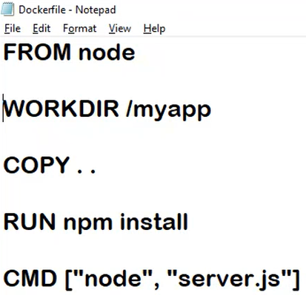

Dockerfile will specify how the image will look like. Image will specify how Container will look like.

Any Dockerfile must begin with **FROM**.

**WORKDIR**:Folder inside the Container that should be considered as Working Directory. When the Container is created, Docker will create a folder named myapp and that folder will be considered as Working Directory.

**COPY . .** : Copy all the contents from the folder where Dockerfile is there and paste them to myapp directory. First . represents the folder where Dockerfile is there. Second . represents the myapp directory.

**RUN**: Can be used to install additional dependencies before application is launched. **E.g. –** node_modules folder. RUN command is executed during the image creation. RUN command is executed when the image is build for the first time. npm install will install all the dependencies in the package.json file. npm install command will get executed from WORKDIR.

**CMD**: Specifies the command to run when Container is created to keep the Container alive. This will create a Web Server which will be running inside a Container.

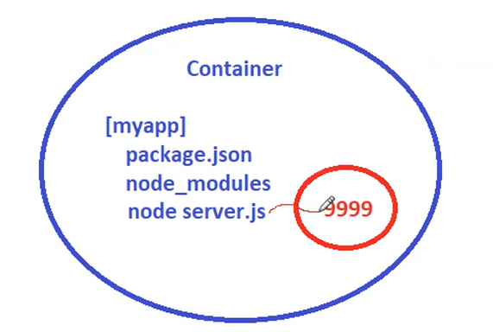

9999 is a Port Number which is exposed by the Container.

**Next task is to Create an Image from Dockerfile.** To create an image, Switch to the folder that contains Docker file.

docker build -t mynodeappimage .

**-t** : TagName. As good as image name.

**.** : Location of the Dockerfile. . means Dockerfile is in the current folder.

docker images: To check the image.

**Next task is to Create a Container from Custom Image.**

docker run -d --name nodeapp mynodeappimage

When the container starts, it will run the CMD command.

docker run ps -a

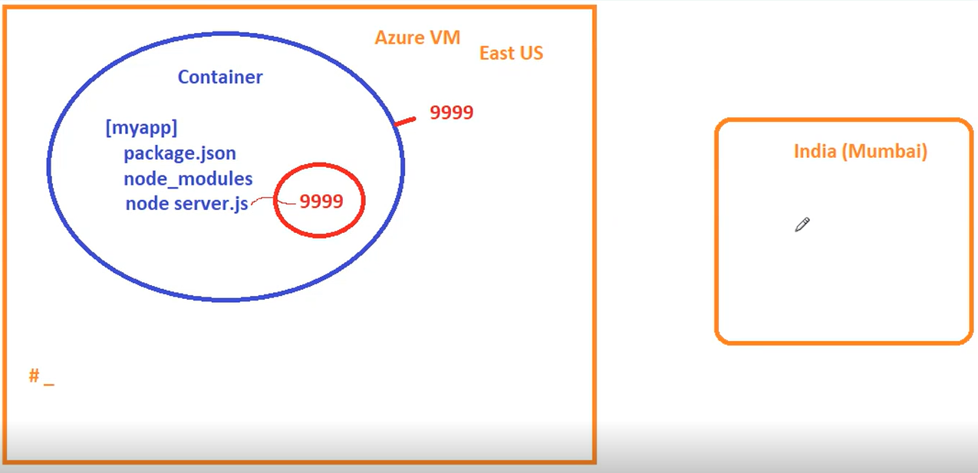

**To remove the image:**

docker image rm <<imageid>>/<<imagename>>

**To Run the Node.Js App:**

Node.Js app in on the Docker Container which is inside your VM.

Node.Js application is exposed on Port No 9999. But this is the Port Number ON the CONTAINER and NOT ON the VM.

Containers have their own internal network. Whenever Container is Created, it is Created inside your Docker Network. This Docker Network is Inside your Docker Host. Hence Port No 9999 is a Port Number can only be identified within the Docker network. When you give a command, you are outside the container, not inside the container. If you go inside the container and give <http://localhost:9999>, it will work.

docker images

Let’s create a Container:

docker run -d --name mynodeapp mynodeappimage

Container will run in the background.

In Linux, you can use “curl” command and specify and URL.

curl <http://localhost:9999>

This command will fail with the following error:

curl: (7) Failed to connect to localhost port 9999: Connection refused

This is because the Port Number 9999 is open on the Container and NOT ON the VM.

To make this work, we have to use a technique known as Port Mapping. Port Mapping is only used in scenarios where the Container needs to be Accessed from Outside.

Containers in the same network can talk to each other using their IP Addresses. Port Mapping is not required in this case. Port Mapping is required only when you are on a different network.

Container Network is different and Docker Host is the different entity. So, if you want to Communicate with the Container from Docker Host, you need to do Port Mapping i.e. Map a Container Port to a Port on Docker Host.

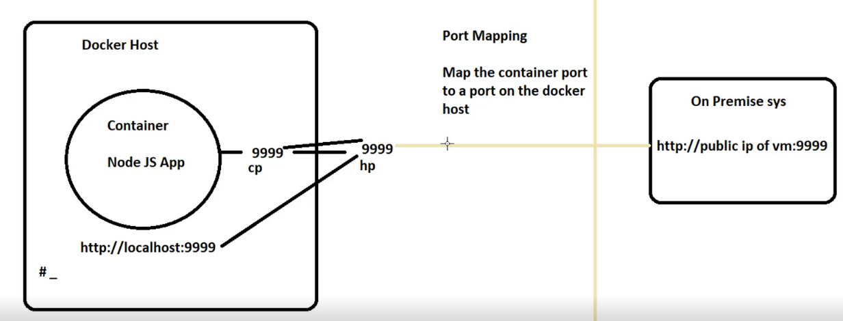

**Remove the Container:**

docker rm mynodeapp --force

**Verify the Container is Removed:**

docker ps -a

**Do the Port Forwarding:**

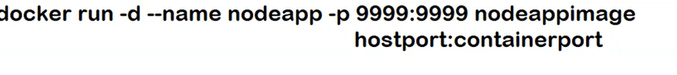

docker run -d --name mynodeapp -p 9999:9999 mynodeappimage

**Verify Port Forwarding has been done:**

docker ps

CONTAINER ID IMAGE COMMAND CREATED STATUS PORTS NAMES

f7cdf4c0033d mynodeappimage "docker-entrypoint.s…" 42 seconds ago Up 41 seconds 0.0.0.0:9999->9999/tcp, :::9999->9999/tcp mynodeapp

**Run the Node.Js App:**

curl <http://localhost:9999>

**Output:**

curl http://localhost:9999

<html>

<head>

<link rel="stylesheet" href="styles.css">

</head>

<body>

<section>

<h2>My Goal is to../h2>

<h3></h3>

</section>

<form action="/store-goal" method="POST">

<div class="form-control">

<label>Your Goal?</label>

<input type="text" name="goal">

</div>

<button>Set Your Goal</button>

</form>

</body>

</html>

**You will see the non-visual (command line) output.**

Try to access this application from your local system using public IP of the VM. You will receive an error. This is because Azure VM is configured to access the inbound traffic on Port No 80.

Hence you need to do the Port Forwarding for Port No 80.

docker rm mynodeapp --force

docker run -d --name mynodeapp -p 80:9999 mynodeappimage

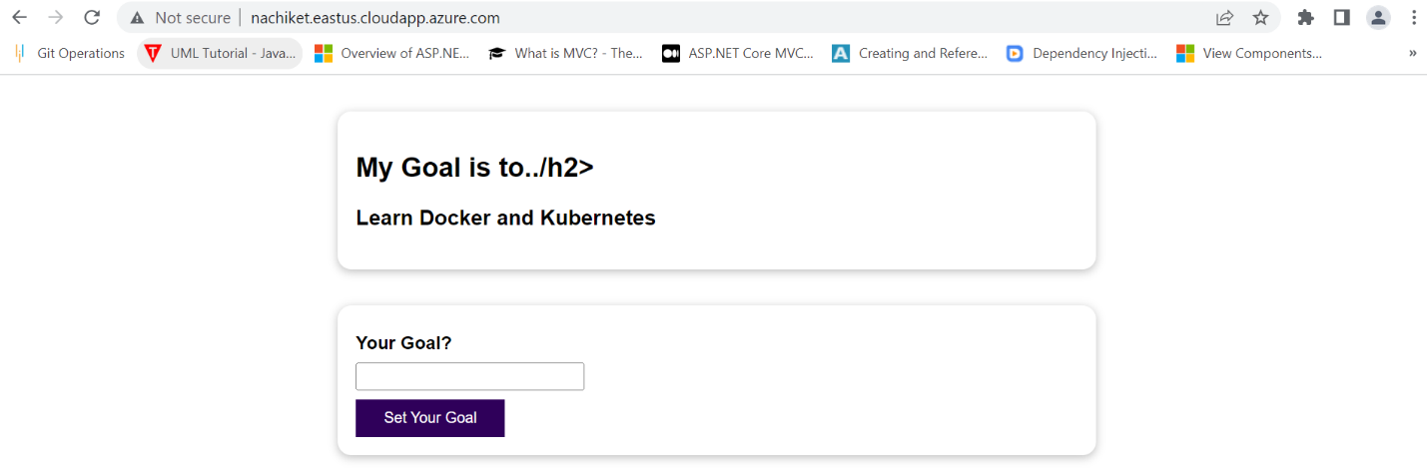

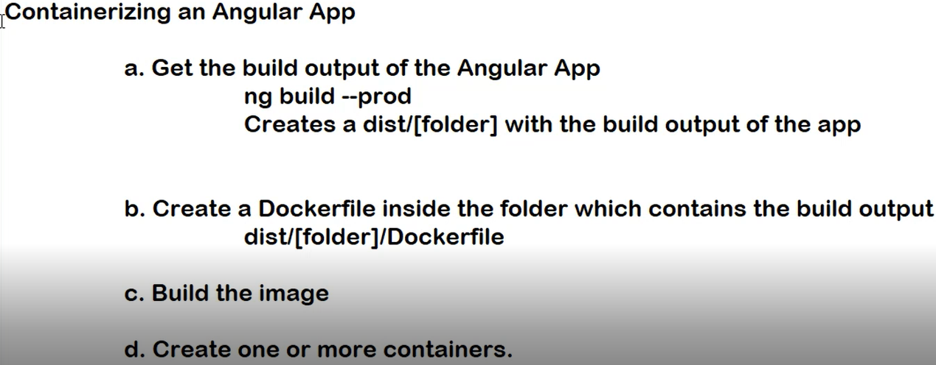

http-server is a lightweight node server needed to host the Angular application.

CMD: Start the HttpServer on the Current Host of the Specified Port No.

**Build the Angular App:**

**ng build –prod**

**Copy** Paste **the Dockerfile inside the Build Output (dist/<<appname>> folder).**

**Build the Image**

**Navigate inside the “karthik-angularapp” folder.**

**docker build -t angularappimage .**

**Remove the existing containers. Otherwise you won’t be able to map application to Port 80.**

**docker rm 0847f096b3be 655ea3123cfe --force**

Create a Container from the Image:

**docker run -d --name angularapp -p 80:4200 angularappimage**

Verify the Container is Created:

**docker ps**

CONTAINER ID IMAGE COMMAND CREATED STATUS PORTS NAMES

270685fe8e69 angularappimage "docker-entrypoint.s…" 7 seconds ago Up 5 seconds 0.0.0.0:80->4200/tcp, :::80->4200/tcp angularapp

**Browse the URL:**

**curl** <http://localhost:80>

**You need to rebuild Image if you make any changes in the Dockerfile.**

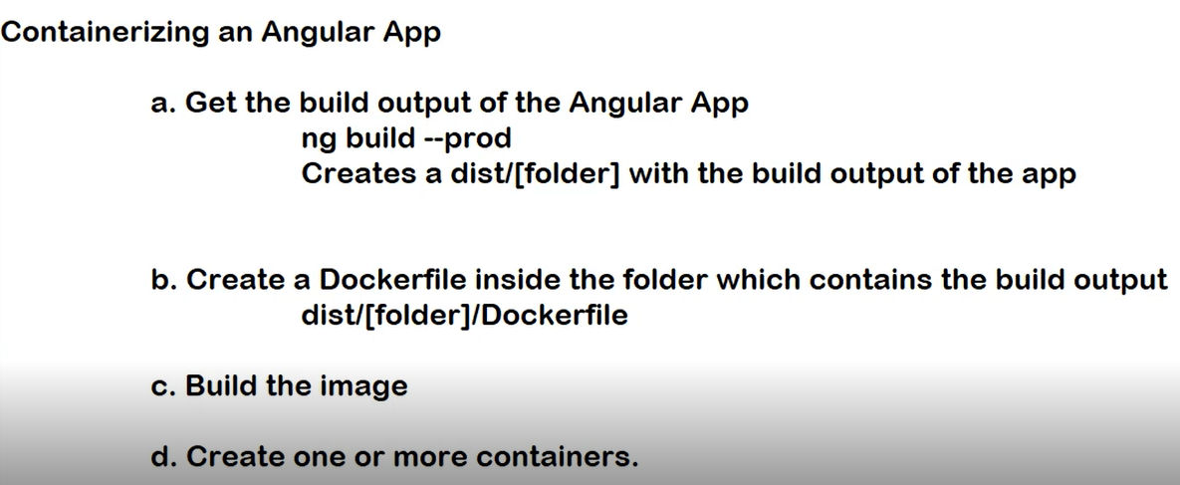

**Image Layers:**

Docker Images are Read-Only.

Docker Images are Layer Based.

Every instruction in Dockerfile creates a layer.

Layer is a binary file.

Image is a collection of binary files and these binary files are stacked on the top of other.

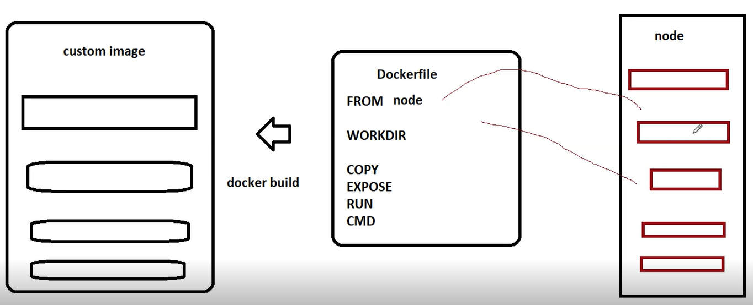

**Benefits of Layers:**

When you specify FROM <<imagename>>, Docker checks if the layers in that image are already present on the local system. If yes, then Docker reuses those Layers instead of downloading them from Docker Hub again. Your custom image will contain reference of binary files already present on your local system.

Hence, layers minimize the time required to build image and pull the existing images from Docker Hub.

Layers will be cached. Whenever Docker encounters FROM instruction, it checks if the layers are available in Cache. If yes, Docker will reuse them.

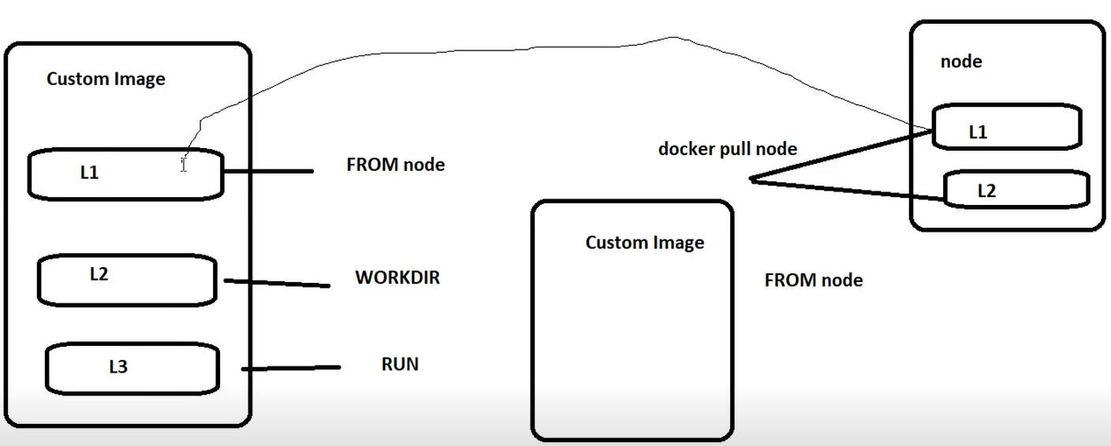

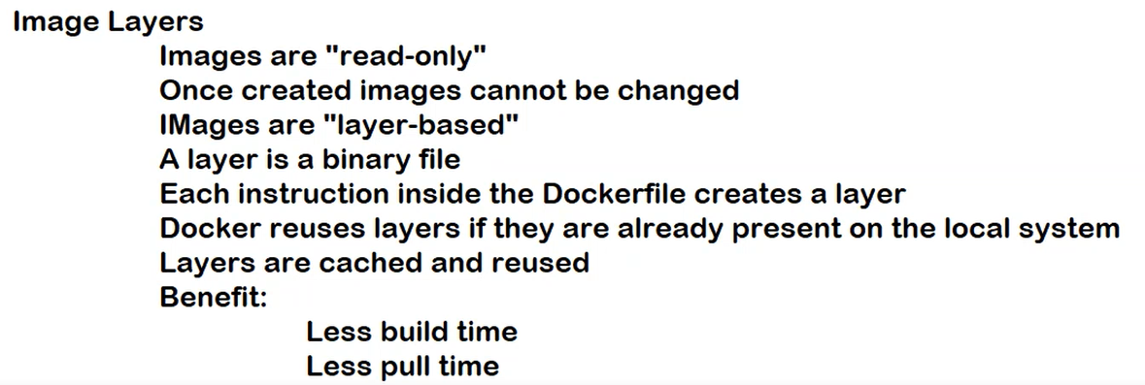

If you rebuild your existing image, Docker will use same layers.

Make some minor changes in the index.html file of the Angular application.

Cut paste the Docker file outside the existing build output.

Build the Angular application again.

ng build - -prod

For Copy . ., docker will not pull the layer from the cache. This layer will be created in the fresh manner.

Whatever instructions change, from that instruction, Docker will rebuild all the layers.

**Containerize an ASP.NET Core Web API Application**

1) Create the build output of the application (Publish it to a folder).

2) Create a Dockerfile inside the folder that contains the build output.

Sample Dockerfile is shown below:

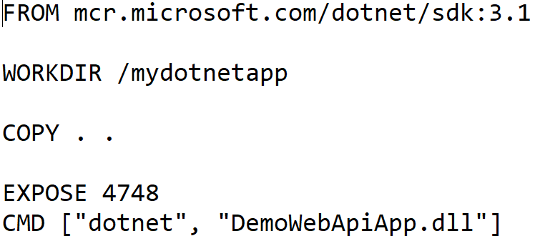

**Image Name Format for Pushing the Image on Docker Hub (Replace imagename with reponame):**



Create a Repository on DockerHub named “dotnet-core-webapis”. You may replace repository name with name of your choice.

Key in the following command to build the image:

**docker build -t << DockerHubUserName>>/<< DockerHubRepoName>>:<<tagname>> .**

**To push the image to Docker Hub:**

1) Log In to the Docker Hub.

**docker login - -username “<<DockerHubUserName>>” - -password “<<DockerHubPassword>>”**

2) Key in the following command:

**docker push <<DockerHubUserName>>/<<DockerHubRepoName>>:<<TagName>>**

**E.g. - docker push nd001/dotnet-core-webapis:v1**

**Replace nd001with your DockerHub UserName and dotnet-core-webapis:v1 with your DockerHub repository name and tag name.**

3) Create a Container from the Pulled Image:

**docker run -d --name webapi -p 5555:5555 nd001/dotnet-core-webapis:v1**

4) Access the Web API Core Application from the browser of your local machine.



5) Try remaining operations on Postman.

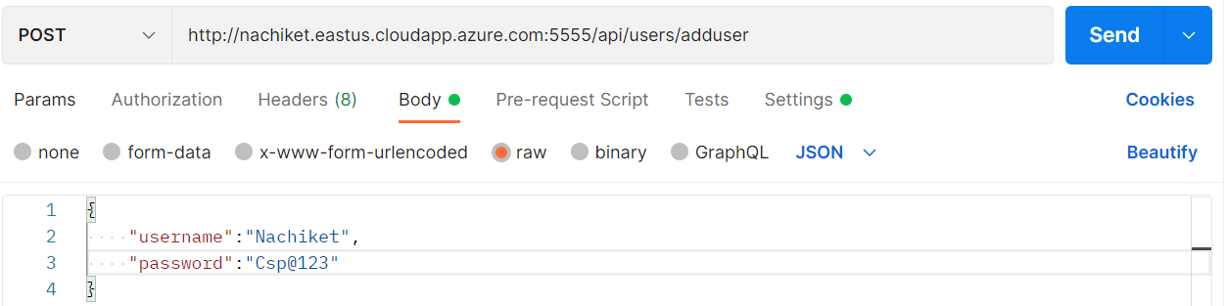

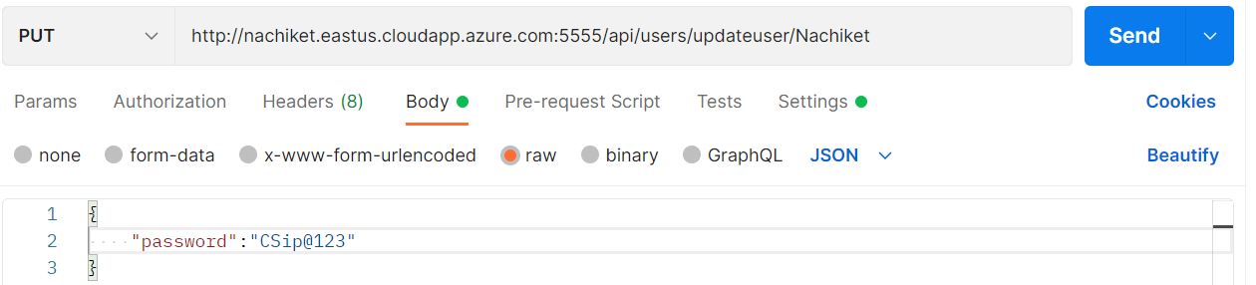

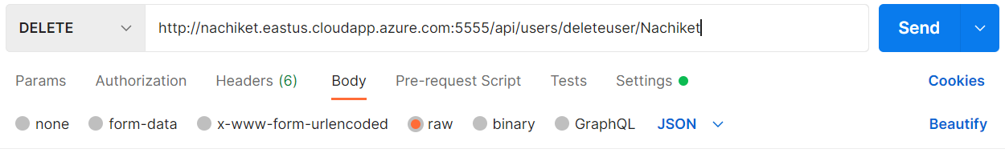

**COMMUNICATING BETWEEN ANGULAR AND WEB API CORE APPLICATION:**

Containers run as a part of the Docker Network and this Docker Network is part of Docker Host.

Default Docker Network is called as a Bridge Network and Bridge Network is Local to the Machine.

Hence by default containers inside a bridge network can communicate with each other.

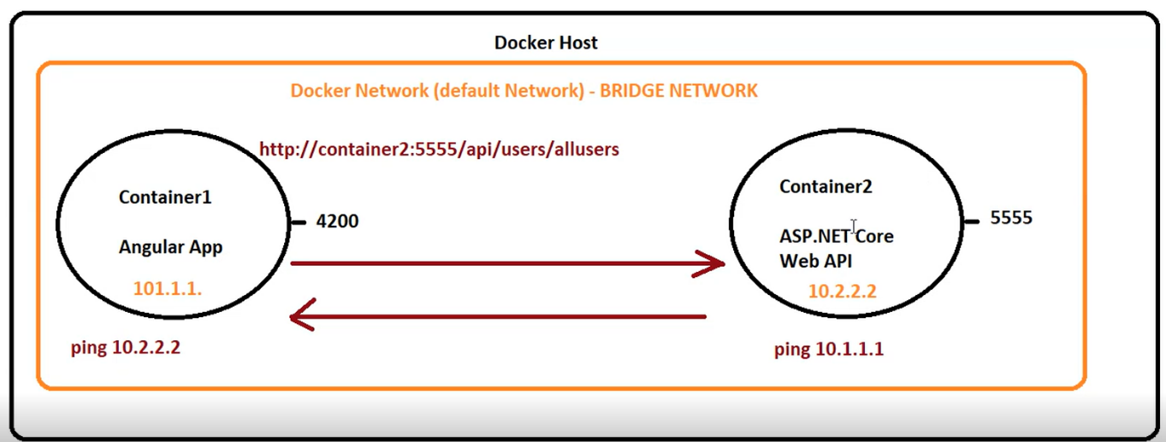

**Docker Networks:**



**Reference URLs:**

<https://docs.docker.com/network/>

<https://www.simplilearn.com/tutorials/docker-tutorial/docker-networking>

<https://thenewstack.io/container-networking-breakdown-explanation-analysis/>

**Network Drivers**

Docker supports networking for its containers via network drivers. These drivers have several network drivers.

In this article, we will be discussing how to connect your containers with suitable network drivers. The network drivers used in Docker are below:

* Bridge
* Host
* None
* Overlay
* Macvlan

### Bridge

* It is a private default network created on the host
* Containers linked to this network have an internal IP address through which they communicate with each other easily
* The Docker server (daemon) creates a virtual ethernet bridge docker0 that operates automatically, by delivering packets among various network interfaces
* These are widely used when applications are executed in a standalone container

### Host

* It is a public network
* It utilizes the host’s IP address and TCP port space to display the services running inside the container
* It effectively disables network isolation between the docker host and the docker containers, which means using this network driver a user will be unable to run multiple containers on the same host

### None

* In this network driver, the Docker containers will neither have any access to external networks nor will it be able to communicate with other containers
* This option is used when a user wants to disable the networking access to a container
* In simple terms, None is called a loopback interface, which means it has no external network interfaces

### Overlay

* This is utilized for creating an internal private network to the Docker nodes in the [Docker swarm](https://www.simplilearn.com/tutorials/docker-tutorial/docker-swarm) cluster
* Note: Docker Swarm is a service for containers which facilitates developer teams to build and manage a cluster of swarm nodes within the Docker platform
* It is an important network driver in Docker networking. It helps in providing the interaction between the stand-alone container and the Docker swarm service

### Macvlan

* It simplifies the communication process between containers
* This network assigns a MAC address to the Docker container. With this Mac address, the Docker server (daemon) routes the network traffic to a router
* Note: Docker Daemon is a server which interacts with the operating system and performs all kind of services
* It is suitable when a user wants to directly connect the container to the physical network rather than the Docker host

### IPvlan:

IPvlan networks give users total control over both IPv4 and IPv6 addressing. The VLAN driver builds on top of that in giving operators complete control of layer 2 VLAN tagging and even IPvlan L3 routing for users interested in underlay network integration.

Both IPvlan and Macvlan remove the need for port mapping and are more efficient.

Microservices deployed in clustered environment creates overlay network.

Containers in two different bridge networks cannot talk to each other.

Only Containers within a bridge network can talk to each other.

**List All the Docker Network:**

docker network ls

All the containers in the bridge network can talk to each other. If you want only few containers to talk to each other, then you need to create a named network.



docker network ls

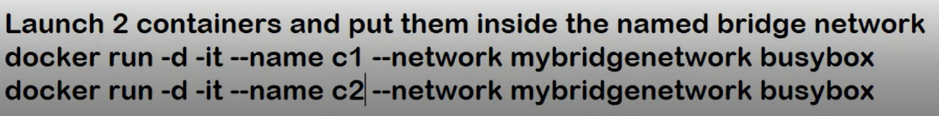

docker inspect c1 🡪 To Check the Network to which Container belongs

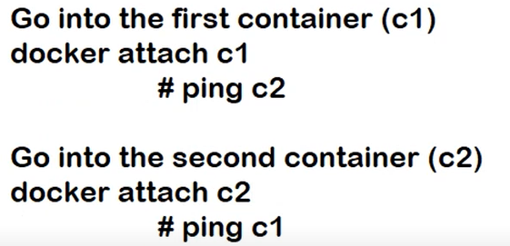

Ctrl+pq to come out.

**Clone the following repository:**

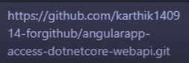

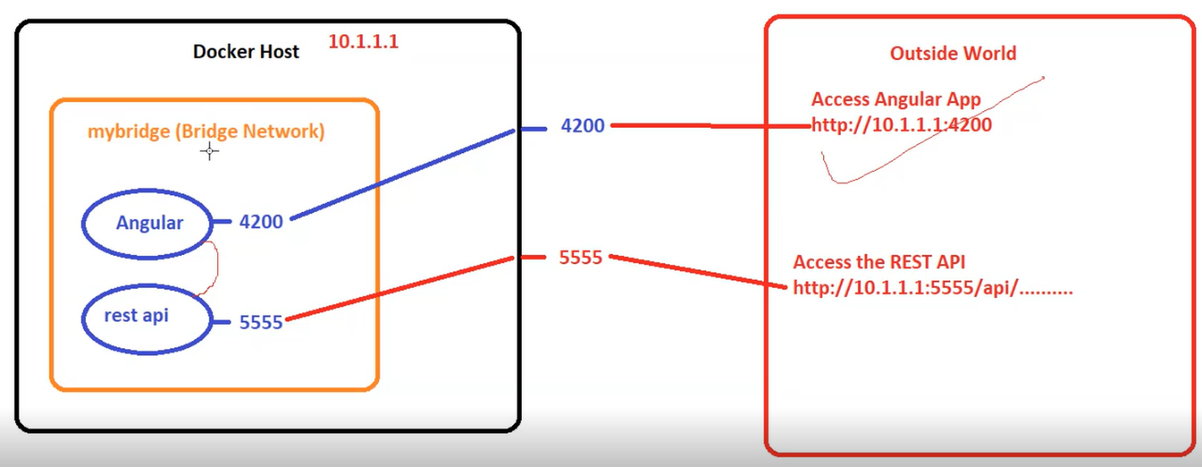

**From the Angular Application, What will be the URL to access REST API Application?**

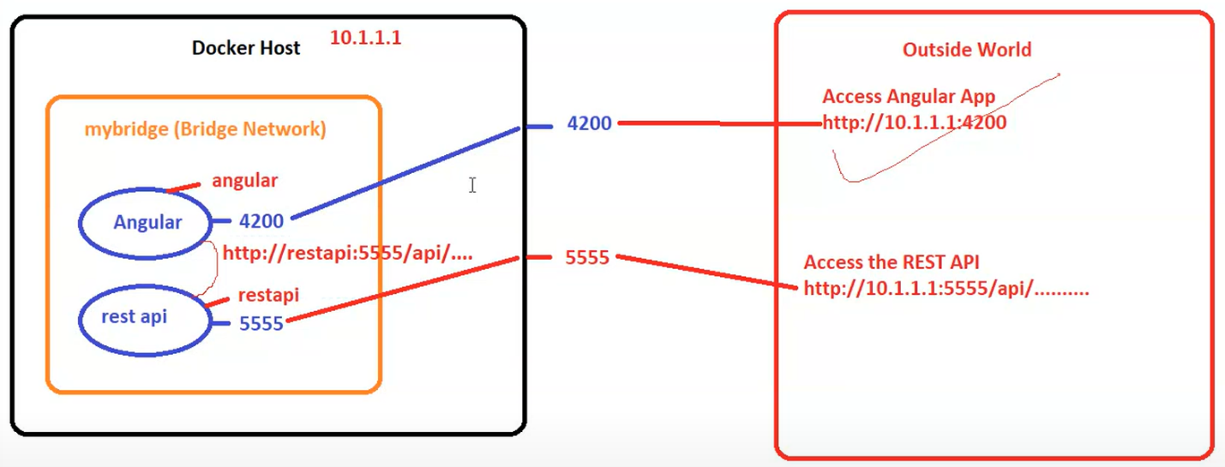

**Logically this is possible. But it will not work.**

**Angular Applications are Browser Based** applications (They run in the browser). Even if you destroy the container, the application will still run in the browser. But if you refresh the page, it will stop working.

That’s what SPAs are. For accessing data, it has to come to server.

When you access the Web API from browser, browser won’t understand the Container is Web API. Hence it won’t work.

